Administrator Workflow Approval Sheet
From your Schools/Department’s tab under the “Workflow Approvals” Click on the words “Go to Workflow Tasklist”
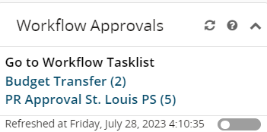
You will see this screen appear click on “Your Tasks” select “Group Task” click on “Choose” and select the transaction.
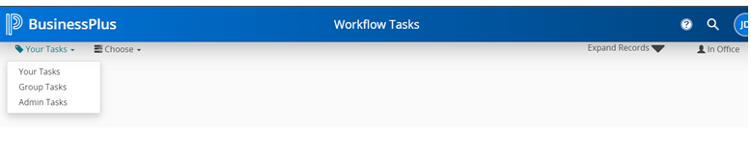Click on the “Choose” and select the transactions you would like to approve based on the Model.
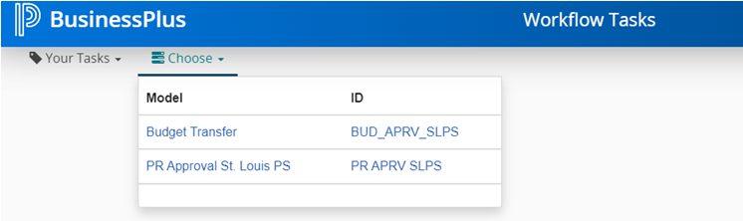

Click on the gray slider to get the approval options to appear.
